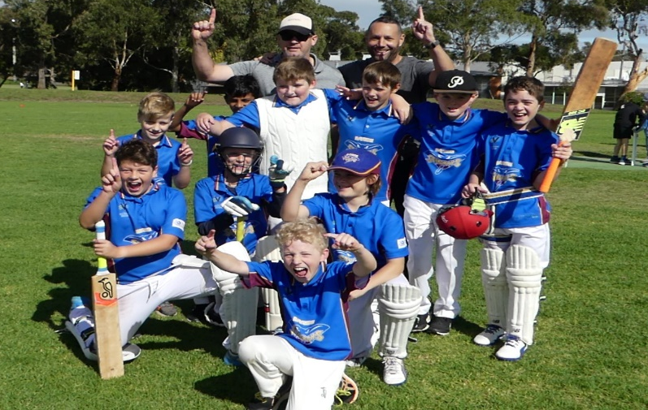
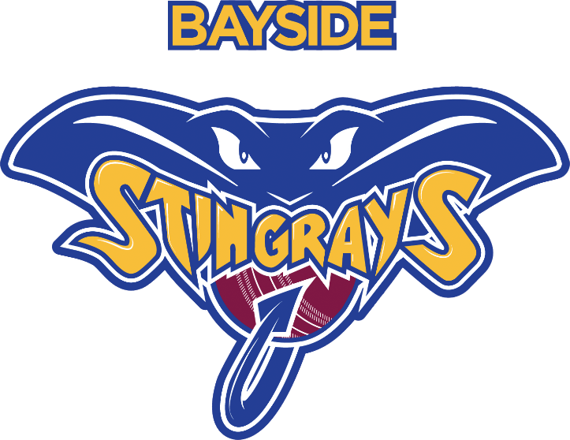
Bayside CC Committee Meeting Minutes

MEETING AGENDA – 10/08/2022

Agenda Topics
- Life Member function
- Working with Children
- Juniors
- Uniform – Hats/Caps

Committee
- Executive Committee
  - Richard Hunter - President
  - <OPEN> – Vice President
  - Piet Bywater – Secretary
  - Greg Sampson – Treasurer
- General Committee
  - Meg Smith - Socials
  - Nigel Barrie – Communications Manager
  - Mark Barrie – Revenue Coordinator
  - Earl Fernando – Canteen/Bar Manager
  - Bridget Roser – Strategy/Growth
  - Paul Sugden – Cricket Mgr
  - Max Ciappara – Membership/Merch

Meeting Attendees: Piet, Richie, Mark, Greg, Nigel, Meg, Bridget
Apologies: Max, Suggo, Earl

Started: 7:30pm
Closed:

Agenda Topic | Comments
Life Member Function | 52 set to come – 14MPCC,14HCC, 17 non life members(8 non committee)  Booklet - TBA  Menu Selection – Barriex2, Hunter to decide  Photography – Barrie Photography Pty Ltd  Badges  Memorabilia Table  Run Sheet to meg – Richie
Juniors | Blaster session @ OLA on a Friday 330-430 in September  Come & Try/registration day/bring a friend around Father’s day 4th September. – including sausge sizzle  WWC for 1st Xi and 2nd Xi (and all captains)
Uniform | Hats/Caps
Child Safety | Shared and Discussed:  - Australian Cricket's Commitment to Safeguarding Children & Young People  - Australian Cricket's Policy for Safeguarding Children & Young People  - Australian Cricket's Code of Behaviour for Looking after our Kids; and  - Cricket Victoria's Member Protection Policy.  On 10th August 2022 the Committee of the Bayside Cricket Club endorsed  • the Cricket Victoria 2022 Member Protection Policy (MPP); and  • Australian Cricket’s Policy for Safeguarding Children and Young People and the Looking after our Kids Code of Behaviour Child Safe Policies  Child Safety Officer – Paul Roser
Working Bee | Container need a clean out  Curator shed needs a clean  Club rooms(footy club)
 | Tablet(s) for Scoring -
Social Media | Child Safety Officer - Paul  Bar/Canteen Manager (or Social Manager)  VP Director of Cricket meed tp fill
Max sponsorship/membership program
Would like a buy in option as well as the slab option
Sponsorship | Dreyfus paid $ and a hamper(potential raffle at launch)  Lewin Real Estate $ + real estate boards at both grounds  Bendigo Bank $ + option going forward  Highett RSL TBA  Burger Bae TBA
 | Players wanted on cricket nets - TBA
 | Committee Whatsapp group – Piet.

Previous Meeting Agreed Actions:

Date: | Item | Actions:

